NEXUS INSTALLATION

**NOTE**

**Every time you stop and start the server you have to run systemctl start nexus**

**Systemctl enable nexus**

**Cd /opt/nexus/bin/./nexus start**

Prerequisites:

It needs atleast 1.8 version java --check using java -version and atleast 2GB RAM so take t2.small

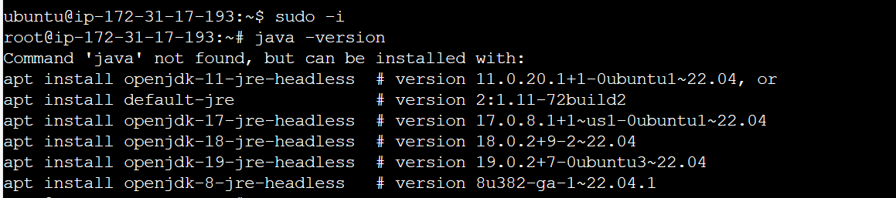

**Check ram using**



Before installing from jdk 8 we need to update and upgrade

apt update && upgrade -y

**apt install openjdk-8-jdk -y**

After installing openjdk-8 check java version

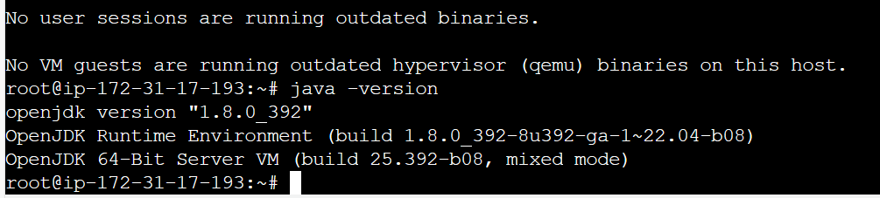

Now copy the tar file from below link using wget

**wget https://sonatype-download.global.ssl.fastly.net/nexus/3/nexus-3.0.2-02-unix.tar.gz**

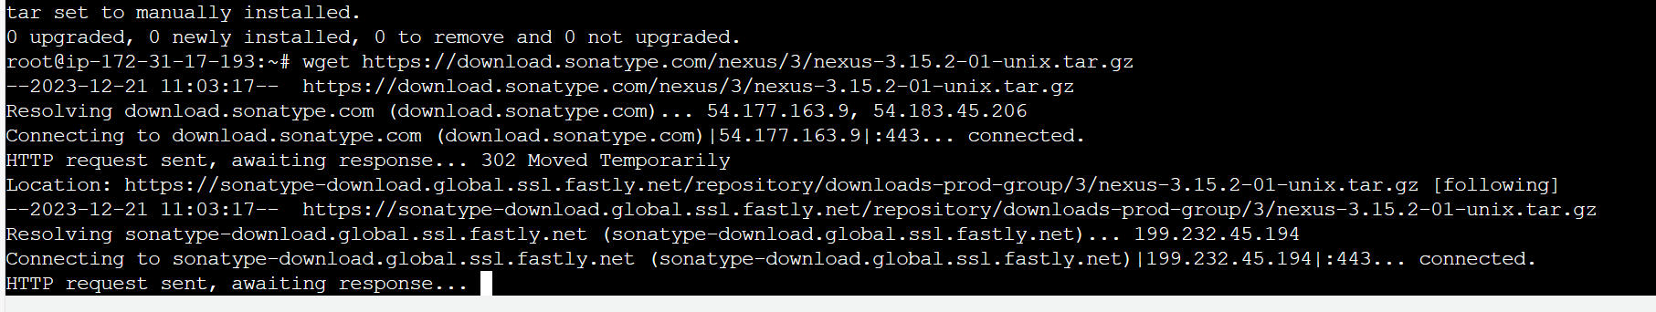

You should be able to see the tar.gz compressed folder in your current directory



NOTE

If you want to download the latest version of nexus use below command

Now you need to decompress the tar file using below command

**tar -xvf nexus-3.0.2-02-unix.tar.gz**

after this you should be able to see decompressed folders

Delete the tar.gz file now using rm -rf **nexus-3.0.2-02-unix.tar.gz**

Now we need a user other than root who can access this two folders before adding user and giving ownership to the user move this third party softwares to opt folder

mv **nexus-3.0.2-02**  nexus3

mv nexus3 /opt/

Now add user nexus and give ownership to nexus user

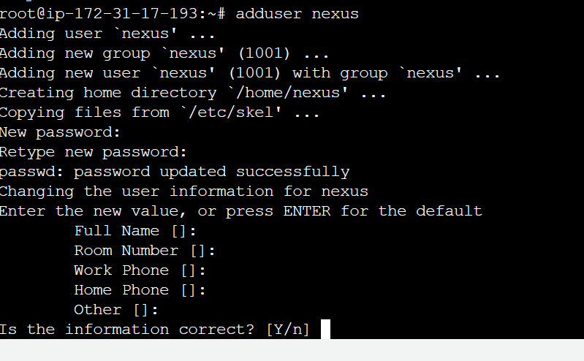

Use below command to give ownership to nexus user

To find uid and gid of user nexus use id nexus

Giving ownership

Chown -R nexus:nexus /opt/nexus3

Its time to add this user in nexus service to run it

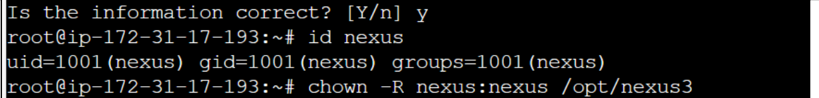

Navigate to below location

Vi /opt/nexus3/bin/nexus.rc



Now run below commands

You need establish a symbolic soft link to activate the service during boot time

**ln -s /opt/nexus3/bin/nexus /etc/init.d/nexus**

**Configure Nexus as a Service:**

Create a Systemd Service File:

Create a file at /etc/systemd/system/nexus.service

with the following content:

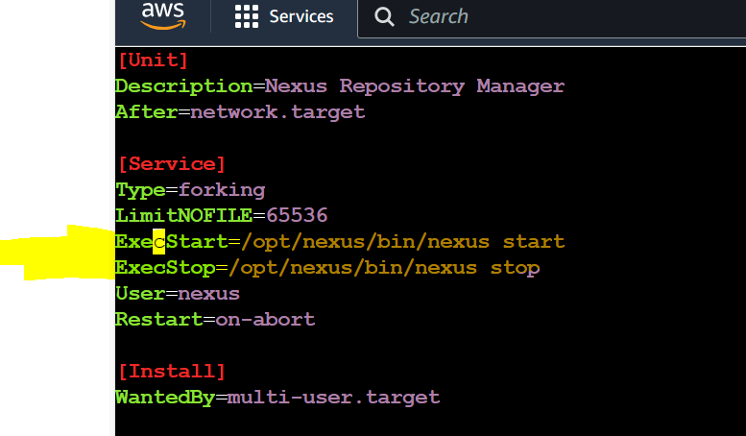

Make sure you change the EXec start and execstop in the above it should be the location where you have installed nexus

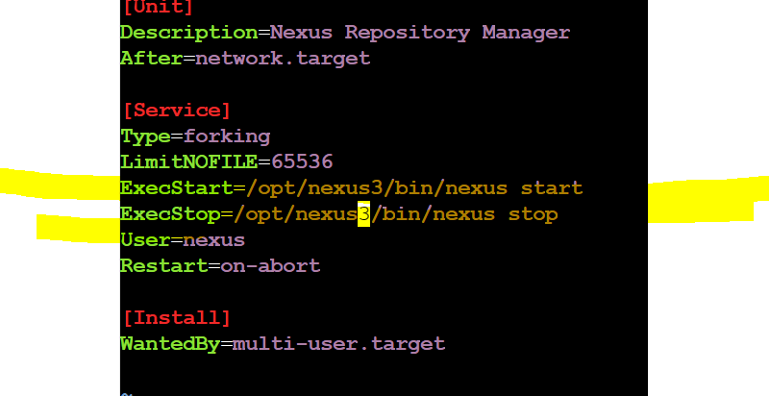

Reload Systemd:

**sudo systemctl daemon-reload**

Start Nexus:

**sudo systemctl start nexus**

Enable Nexus to Start on Boot:

**sudo systemctl enable nexus**

The systemd service file is a configuration for managing the Nexus Repository Manager as a service on a system that uses systemd for process management. This setup allows Nexus to start automatically when the system boots, and it provides a standardized way to manage the Nexus process.

1. **Unit Section:**

- `Description`: A human-readable description of the service.

- `After`: Specifies that the Nexus service should start after the network is up.

2. **Service Section:**

- `Type`: Specifies the process start-up type. In this case, it's set to `forking`, indicating that the process forks into the background.

- `LimitNOFILE`: Sets the maximum number of file descriptors that the Nexus process can use.

- `ExecStart`: Specifies the command to start the Nexus service.

- `ExecStop`: Specifies the command to stop the Nexus service.

- `User`: Sets the user under which the Nexus service should run.

- `Restart`: Specifies when the service should be restarted.

3. **Install Section:**

- `WantedBy`: Specifies the target that this service should be part of when enabled. In this case, it's set to `multi-user.target`, meaning the service is part of the multi-user system.

Using a systemd service file provides several advantages:

- **Standardization:** It adheres to the systemd standard, making it consistent with other services managed by systemd.

- **Automation:** It allows Nexus to start automatically during system boot.

- **Control:** You can start, stop, restart, and check the status of the Nexus service using standard systemd commands (`systemctl`).

Regarding symbolic links, you might be referring to creating symbolic links in the `/etc/systemd/system/` directory to the actual service file. This is a common practice, and it allows you to manage services using standard `systemctl` commands without having to use the full path to the service file.

For example, after creating the service file at `/etc/systemd/system/nexus.service`, you might create a symbolic link to it like this:

This creates a symbolic link in the `multi-user.target.wants` directory, effectively enabling the service to start at boot.

**sudo ln -s /etc/systemd/system/nexus.service /etc/systemd/system/multi-user.target.wants/nexus.service**

==========================================================================

After this you need to start the nexus server and enable the services

Systemctl start nexus

Systemctl enable nexus

After this start the nexus using below command

/opt/nexus3/bin/-->./nexus start

After this check service is active or not using

Systemctl status nexus it should active and check the url:8081 you should be able to see nexus ui like shown at the end pf the page

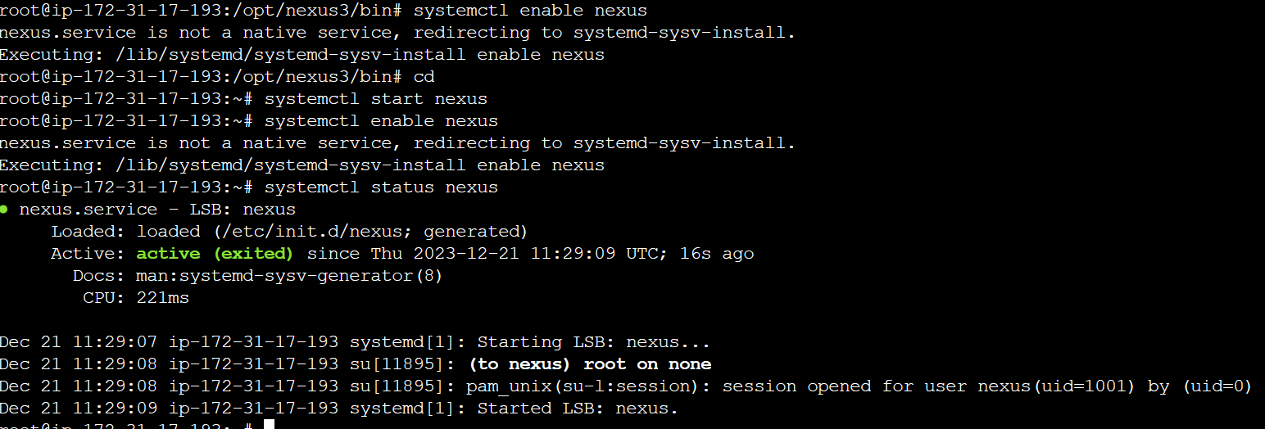

IN the above picture you can see nexus is started using root user adding nexus user to sudo check at end of the page

Suppose if you don’t want to start using root user then you need to give some user access to the sudo file as services are run by root user default

As we created user named nexus we will add him to the sudo file

Visudo

Give root previleges to nexus user

In sudoers file

visudo

<username> ALL=(ALL:ALL) NOPASSWD: ALL

nexus ALL=(ALL:ALL) NOPASSWD: ALL

Now switch to nexus

Open /opt/nexus/bin/./nexus start

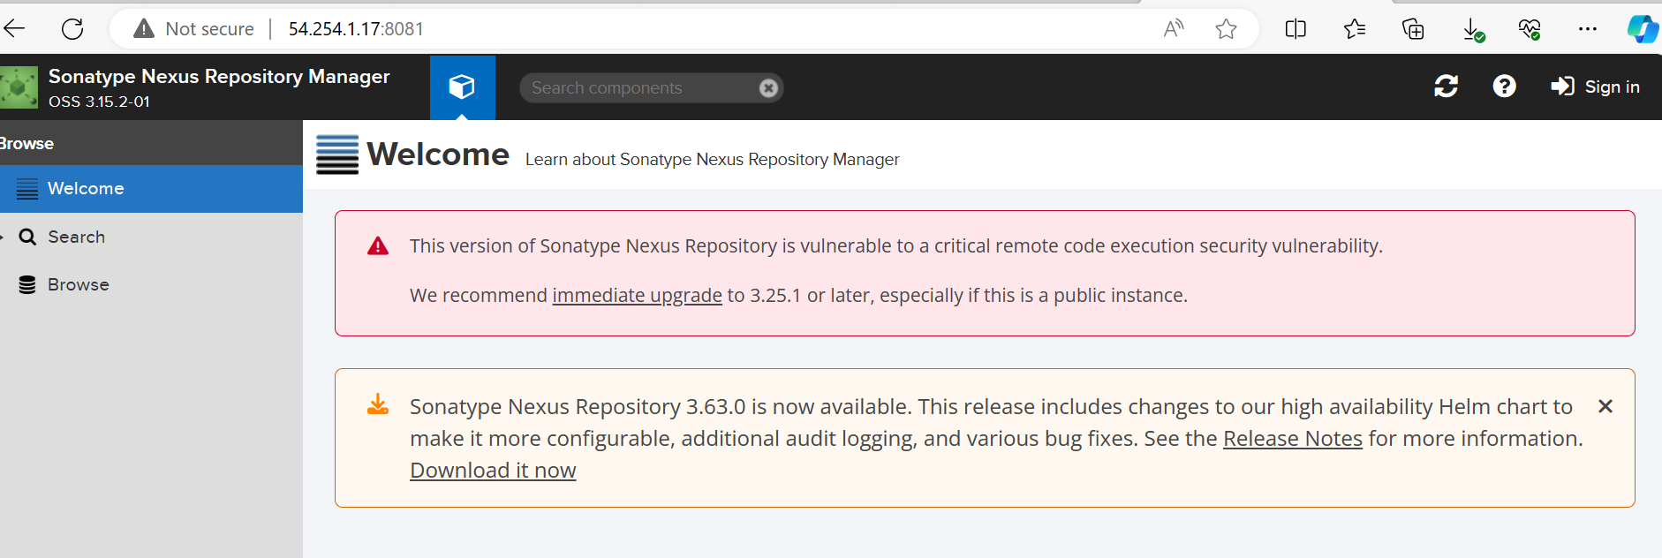

**Commands used**

**sudo -i**

**apt update && upgrade -y**

**apt install openjdk-8-jdk -y**

**wget https://sonatype-download.global.ssl.fastly.net/nexus/3/nexus-3.0.2-02-unix.tar.gz**

**tar -xvf nexus-3.0.2-02-unix.tar.gz**

**rm -rf nexus-3.0.2-02-unix.tar.gz**

**mv nexus-3.0.2-02 nexus3**

**mv nexus3 /opt/**

**adduser nexus**

**chown -R nexus:nexus /opt/nexus/**

**visudo**

**nexus ALL=(ALL:ALL) NOPASSWD: ALL**

**su nexus**

**vi /opt/nexus3/bin/nexus.rc**

**uncomment**

**runasuser="nexus'**

**vi /etc/systemd/system/nexus.service**

**add this**

**[Unit]**

**Description=Nexus Repository Manager**

**After=network.target**

**[Service]**

**Type=forking**

**LimitNOFILE=65536**

**ExecStart=/opt/nexus3/bin/nexus start**

**ExecStop=/opt/nexus3/bin/nexus stop**

**User=nexus**

**Restart=on-abort**

**[Install]**

**WantedBy=multi-user.target**

**ln -s /opt/nexus3/bin/nexus /etc/init.d/nexus**

**ln -s /etc/systemd/system/nexus.service /etc/systemd/system/multi-user.target.wants/nexus.service**

**systemctl daemon-reload**

**systemctl start nexus**

**systemctl enable nexus**

**cd /opt/nexus3/bin/**

**./nexus start**

**systemctl status nexus**